Design Journal

File Name: Stem.SLDPRT
Description: Part in Underground Water Sprinkler
Material: Plastic

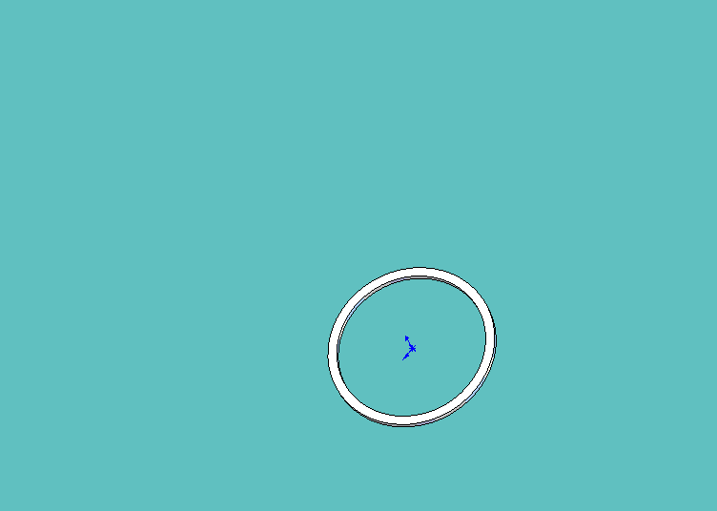1. Extruded bottom of Stem
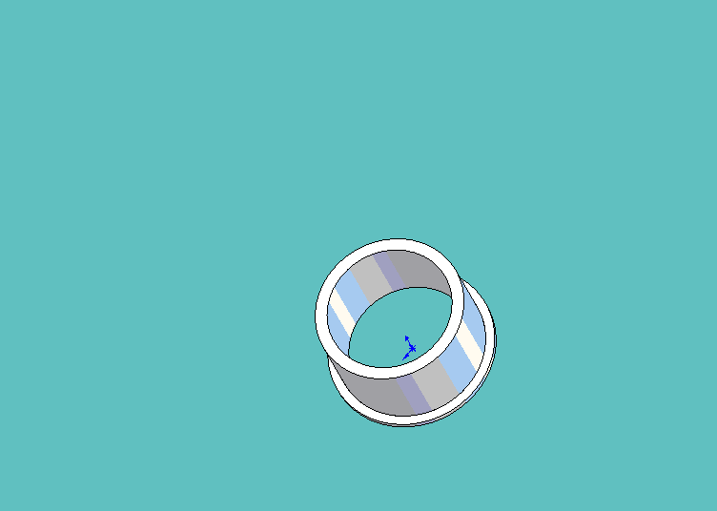2. Extruded next part of stem
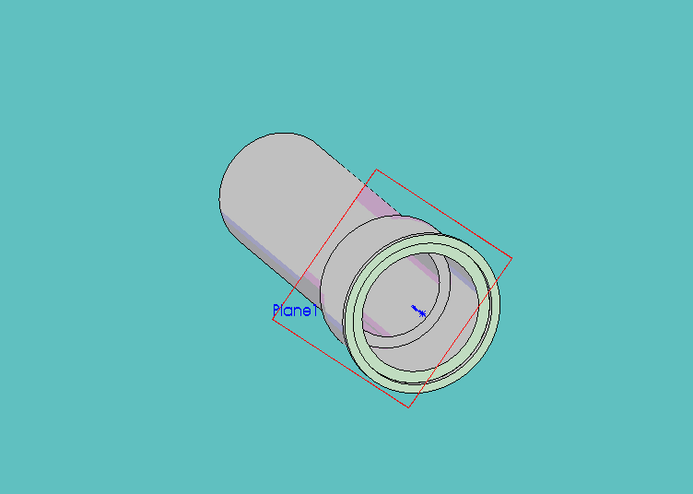3. Created a plane and then extruded from plane.
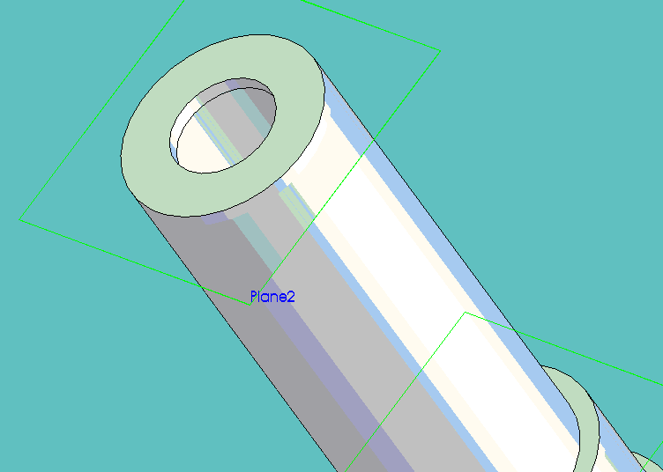4. Created another plane at top and extruded from that.
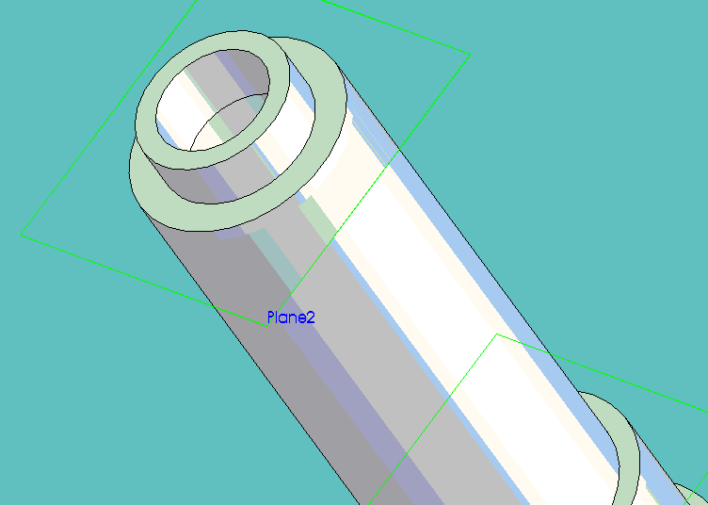5. Extruded final part.
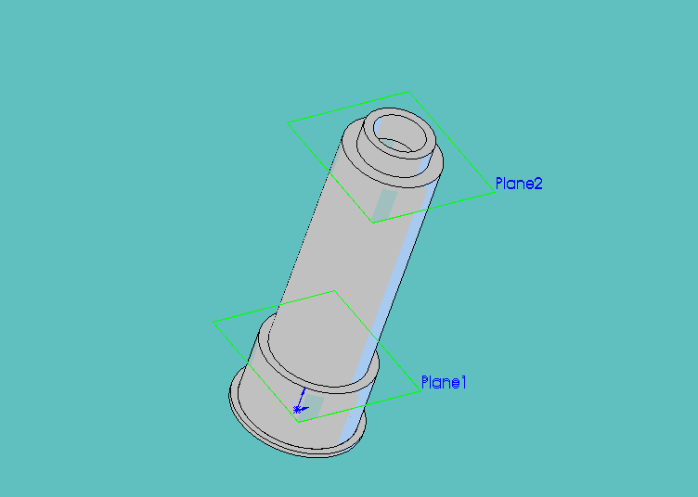6. Final piece

